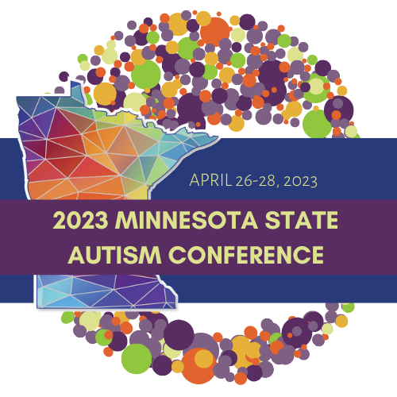

Thank you for considering submitting an application to present at the 28th Annual Minnesota Autism Conference. This document will provide you with guidance and answer common questions about the application form. If you have additional questions about your presentation or the application process, please reach out to Maura McDonald at mmcdonald@ausm.org.

Suggested Topics
We welcome submissions on all topics, however the list below provides ideas and suggestions of topics that our community has requested.
- Employment
- Mental health (including anxiety, co-occurring diagnoses, PTSD and trauma, drug and alcohol addiction, etc.)
- Gender identity
- Emotion regulation
- Social skills
- Sensory integration/supports
- Alternative and Augmentative Communication
- Current research
- School supports
- Early intervention
- Supports and strategies for parents, siblings, educators, and providers
- Transition
- Behavior
- Housing
- Aging
- Executive function
- Sex/sexuality/dating
- Service navigation
- Sensory supports
- Ableism

Factors Affecting Selection
The purpose of the Minnesota Autism Conference is to provide a wide range of information to those affected by autism. Our goal is to offer relevant information for participants at all levels, including those who are new to autism and those who have years of experience. The following factors will be considered when selecting proposals:
Thoughtful completion of ALL sections of the proposal and adherence to directions.
- Relevance to conference participants.
- Number of presentations on the same or similar topics and/or subtopics.
- Content-area coverage.
- Presenters’ apparent level of expertise.
- Professional and geographic distribution of presenters.
- Presenters and topics reflective of the diversity of our community.

Presenter Roles & Responsibilities
All presenters will:
- Confirm commitment to present within one week of notification of selection.
- Register for the conference if participating in other sessions.
- Refrain from changing the title/content of the session after the proposal has been accepted.
- Provide a PowerPoint presentation by April 7, 2023. The PowerPoint presentation will be converted to PDF handouts and placed on a central website for conference participants to print on their own.
- Adhere to Universal Design Guidelines (provided upon acceptance).
- Provide their own laptop computer, including microphone and video, to record or stream their presentation.
- Adhere to all deadlines specified in the proposal form.
- Be available all three days of the conference. The AuSM committee will place each session at a particular time in the schedule, and it is difficult to change once we have created the schedule. If you need a particular time as an accommodation, please indicate this in the application and your request will be honored.

We do not offer an honorarium nor cover expenses for breakout session presenters. Presenters will be offered a discounted rate to attend the conference. Participants of the conference appreciate clear topic descriptions of what to expect during your session. If selected, your presentation must be consistent with the description provided in your proposal.

Accommodations
AuSM is happy to provide accommodations at any step in the process, from applying to speak through the day of the event. If you need accommodations during the application process, please reach out to Zephyr James at zjames@ausm.org. Common speaker accommodations include:
- Time to practice your presentation with an AuSM staff member.
- Additional reminders of due dates.
- Quiet space before or after your presentation.
- All speakers are welcome to wear anything that makes them feel comfortable, including sunglasses, hats, etc. as well as bring fidgets or tools to make presenting more accessible.

