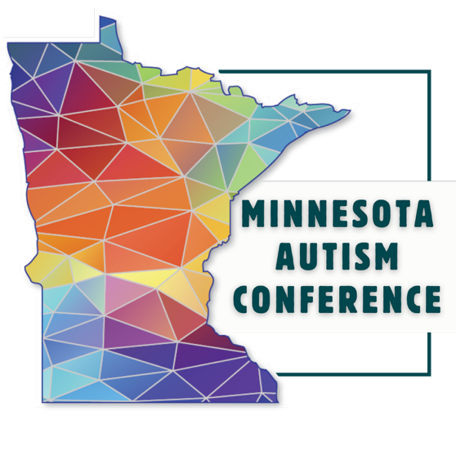
Apply to Present at the 2026 Minnesota State Autism Conference

To complete an application to present at the 2026 Minnesota State Autism Conference, you will need to fill out the digital form located here: https://ausm.org/apply-to-present-at-the-2026-minnesota-autism-conference/

If you would like to work on your application over time or with others, we have created this draft form using Microsoft Word so that you may save and share information as you work on it. When you’re ready, copy and paste your answers into the online form. Don’t forget to select the “submit application” button.

If you have questions about the submission process or your presentation, please reach out to Megan Anton at manton@ausm.org. Breakout sessions will be delivered in person April 14-16, 2026 at the Doubletree by Hilton Minneapolis Airport Hotel. When we select breakout presenters, we expect that you are available both days of the conference.

In the event that AuSM is not able to hold the conference in person, breakout session presenters may be asked to present virtually. Additionally, select speakers may be asked to record their sessions to be made available on demand for conference attendees.

We do not offer an honorarium nor cover expenses for breakout session presenters. Speakers will receive complimentary admission on the day they are scheduled to present plus a discounted rate to attend the entire conference.

Participants of the conference appreciate clear topic descriptions of what to expect during your session. If selected, your presentation must be consistent with the description provided in your proposal.

Breakout presentation proposals are due by Friday, Nov. 7, 2025. You will be notified through email by Dec. 12, 2025 whether or not your proposal is selected.

Presenter Roles & Responsibilities

All presenters will:
- Confirm that you are still willing and able to give your presentation within one week after we let you know you’ve been chosen.
- Keep the title and the content of the session the same after the proposal has been accepted. The committee may ask you to make some adjustments to your title or description. We will ask you when we tell you your proposal has been accepted.
- Provide a PowerPoint presentation by March 19, 2026 if you will be using one during your presentation. We will share your slides on our website for the people who attend to print out.
- Follow the Universal Design Guidelines, which are ways to make your presentation more accessible. We will send you these guidelines if we choose you as a presenter.
- Every room at the conference will have a projector and a microphone for you to use. If you need any other equipment to present, you will need to bring it yourself. If you use a Macbook computer, you might need to bring an adapter to connect your Macbook to the projector.
- Follow all deadlines we give in this proposal form.

Factors Affecting Selection:
The purpose of the Minnesota state autism conference is to provide a wide range of information to those affected by autism. Our goal is to offer relevant information for participants at all levels, including those who are new to autism and those who have years of experience. The following factors will be considered when selecting proposals:
- Thoughtful completion of ALL sections of the proposal and adherence to directions.
- Relevance to conference participants.
- Number of presentations on the same or similar topics and/or subtopics.
- Content-area coverage.
- Presenters’ apparent level of expertise.
- Professional and geographic distribution of presenters.
- Presenters and topics reflective of the diversity of our community.

Presenters
While in past years, AuSM has accepted applications for larger panels, in 2026 we are limiting the number of speakers per presentation to 4 (including moderator) for logistical and quality reasons.
The following information will be required for each presenter in your session:
Presenter:

Name:

Pronouns:

Email:

Phone:

Please provide a short biography of the presenter. 100 words or less. If it is longer than that, we will edit it. This will be included on the conference website and in the program if your presentation is chosen.

Presentation Information

Title of Presentation:

Summary of presentation. This will be included in the conference program if your session is selected. This is the description that participants will see and is your chance to promote your session. Summaries may be edited.

In your session summary, you had to describe your session in just 100 words. We recognize that may not be enough words. If you would like to share more information about your session, use this box to do so. This will not be included in the conference program.
Suggested information to include:
-Explain the problem you are talking about
-Give interesting points of view on your topic, or a point of view that causes arguments.
-Explain what parts of the topic your presentation will address.
-Share what unique insight you’ll bring.

Conference participants appreciate sessions that teach strategies, skills, or clear knowledge. Please share what you hope people will take away from your session. You can share in a paragraph form or in bullet points.
For example: participants will learn the most effective way to write budget line items in a waiver or participants will have new strategies for using a planner to support executive function.

Mo
Intended audience: please check all audiences for whom your session is applicable.
- Autistic individuals
- Direct Support Providers (including community service providers, case managers, job coaches, etc.)
- Educators (including paraprofessionals, administrators, etc.)
- Family Members
- Professionals (including BCBAs, mental health therapists, occupational therapists, physical therapists, speech language pathologists, etc.)
Life Stages: please choose the age ranges that your session will address.
- Birth to five
- School age
- Transition to adulthood
- Adulthood
- Older adult
- All life stages

We recognize and celebrate the diversity of our community members, and we are looking for presentations that show this diversity. We think it is important to represent those who have not been allowed to speak in the past. We want to give these people chances to be heard, to help their messages reach more people, and learn from what they teach us. We expect all the presentations to talk about developmental disabilities like autism. Please tell us if your presentation will also cover any of the following topics:
- Complex or multiple disabilities
- Mental health conditions
- Non-speaking communication or AAC
- LGBTQIA or gender diversity
- Racial or cultural diversity
- Aging
- Greater Minnesota or Wisconsin/rural communities
- None of the Above
To help the committee understand your presentation better, share some information about how your presentation will include the diverse groups you checked in the previous question. What issues will you address? How is it relevant to these groups?

We want the people who present to be as diverse as our community is. To help us do that, we ask that you share more information about your identity, as you are comfortable. Please select the groups you identify with:
- I have a developmental disability (for example: autism, ADHD).
- I have a physical disability.
- I have complex or multiple disabilities.
- I have a mental health condition.
- I am non-speaking, unreliably-speaking, or use AAC.
- I am LGBTIA+
- I am a person of color or otherwise identify as a racial minority
- I am a senior/part of the elderly community.
- I live in a rural community.
- I prefer not to answer.

Do you require accommodations during your presentation (e.g., technology support, a particular timeslot, etc.)? Please do not request a particular timeslot if you do not need one as an accommodation.
If your presentation is not selected, we may have other opportunities for you. Please check the opportunities you would be interested in if you are not selected.
- I would like to be an alternate. You can contact me if another presentation falls through and I would like to fill in.
- I would be interested in speaking on a panel.
- I am not interested in these opportunities.
-I am available to speak virtually.

